|  |  |
| --- | --- |
| **Name:** | Kong Mun Jun, Lee Chun Xian, Lee Jun Xian |
| **Programme:** | RDS2 |
| **Tutorial Group:** | G3 |
| **Research Title:** | A study on the relationship of the advantages of Multiplayer Online Battle Arena (MOBA) games, usability and Gender Equality |

|  |
| --- |
| **Introduction** |
| In the risen of the computer games era, there are many types of computer games among several choices provided by different platform for gamers that used to attract them for paying much attention and stamina sitting front of the computer, which is called as Multiplayer Online Battle Arena (MOBA) Games. However, some highlights about the MOBA games which are built-up or matching up with other strangers as a team and each of the teammate plays essential role on manipulate their own character to destroy the base camp of the opponent to get victory of the game. Other than that, MOBA games tend to be tendency in recently because of people are more focus on aiming to get victory in-game and contribute their own ability to strengthen up the entire team therefore fascinate many players to play MOBA games and inspired them for establishing strong teamwork spirit in every their games. Examples of such games are *DOTA2*, *League of Legends (LOL)*, and *Vainglory.* |
| **Research Problem Statement** |
| Back in the days where video games were just a thing peoples do to past time, it is safe to say that video games were popular among boys and were rarely seen girls playing video games at that time. Even until now where video games are becoming E-sport and are what people do for a living just by streaming themselves playing video games, although the number of female gamers is increased, the community is still not diverse enough to overthrow the idea of “gaming is for boys”. Other than, achieving the ultimate goal of gender equality, having a somewhat balance diversity as your user for a game is important because if you do then you will have the market to target. |
| **Research Objectives** |
| The objective of this research is to access the worth of Multiplayer Online Battle Arena(MOBA) game by studying the relationship between gender equality in terms of numbers, consistency of gamers playing the game, and the growth that happens to be improved after a long period of gaming. Furthermore, the correlation of genders and experience will be evaluated as well with the aspects of the attractiveness of the games, the layout designs, and user satisfaction in this study. |
| **Research Questions** |
| 1. Is there any relationship between Gender Equality and Consistency of gamers and Growth proved after a long period of gaming? 2. Will MOBA games recommend growth and development to teenagers in terms of brain development?? 3. What would gamers prefer in the games, User Interface, Character Designs, or Storylines in the games?  |  | | --- | | **Research Hypotheses/Sub-objectives** | | 1. There is a correlation between Gender Equality and Consistency of gamers and Growth proved after a long period of gaming. 2. There will be more male players than the female player in MOBA genre games. 3. MOBA games will recommend growth and development to teenagers in terms of brain development. 4. There is an interaction between Gender and experience of User Interface. 5. There is an interaction between Gender and experience of Character Design. 6. There is an interaction between Gender and experience of Game Storylines. 7. Girls have weaker skills than boys in Gaming. 8. Gaming is an unhealthy activity towards society. | | **Methodology** | | This research collects data by conducting surveys as our method for research. The survey questionnaire will be complete by a sample of 300 respondents (will be further explained in the Sampling section) aged between 13 to 33, mostly in Selangor, Kuala Lumpur, Malaysia. This sample group is selected as Computer Games trends started and progressing around the age of theirs. | | **Research Instrument/Data Collection** | | **Instrument 1: Questionnaire**  The instrument used in this research is the Questionnaire. The questionnaire is divided into 4 sections which are the Demographic, Gaming Experience, Usability, and the Gender Issues in Game.  The demographic section will ask about some questions about gender, ages, and the occupation to separate the participants into a few categories for us to easily analyze the next few parts of our research. The second part will be the Gaming experience where we will have our questions focus on the MOBA type gaming experience from the participants. Whereas in the Third Part, we will ask about the usability in the games from the aspects, reasons, and effects. Last but not least, in the Gender Issues part, we will ask the participants some thoughts about gender issues that happen in the games.  Our Questionnaire used various scales to have more visual and easy analysis from the response. First of all, Nominal Scale will be used for some Yes or No Questions and some Demographic questions such as Genders; which 0:male, 1:female or 0:No, 1:Yes. Likert Scale also will be used in some Rating Questions such as rating how much they like a game, 1:Very Dislike to 5:Like Very Much. Open-ended questions will be asked in the Questionnaire.  No pressure is given to the respondent which will ensure that Hawstrone effect is not happening that will affect the conclusions. | | **Validity and Reliability Consideration** | | Validity refers to how accurately a method measures what it is intended to measure (Middleton, 2019). Thus, the questions prepared in the questionnaire are only related to the attractiveness of MOBA games, the usability of games, and gender issues in the games to ensure the validity of the research. All of those questions can conclude the level of addiction of both genders in Gamings. Tilo and Christoph (2017) state that Many studies conducted in social science fields such as psychology report that girls and young women display less interest in digital games, have less game-related knowledge, and play less frequently and for shorter durations than do boys and young men ([Brown, Hall, Holtzer, Brown, & Brown, 1997](https://academic.oup.com/jcmc/article/11/4/910/javascript:;" \t "_blank); [Cassell & Jenkins, 1998a](https://academic.oup.com/jcmc/article/11/4/910/javascript:;" \t "_blank); [Lucas & Sherry, 2004](https://academic.oup.com/jcmc/article/11/4/910/javascript:;" \t "_blank); [Wright, et al., 2001](https://academic.oup.com/jcmc/article/11/4/910/javascript:;" \t "_blank)). therefore, this proves that there is a strong correlation between the attractiveness in games and the number of both different genders involving in computer games.  Moreover, Reliability is defined as to the extent which a research instrument consistently has the same results if it is used in the same situation on repeated occasions (Heale and Twycross, 2015). Hence, the participants will be required to fill in every part of the questions in the questionnaire to ensure consistency of numbers and percentages for every part to be analyzed. Besides that, every question was created in a form of short, easy to read, and understandable for participants as we considered our respondents' ages between 13 to 35. Bilingual also under our consideration where we also translated the questions into Chinese to prevent some respondents who did not grow up understanding the English language. To bring the best performance in our surveys, we pre-tested with our questionnaire and sample responses gathered by our teams will be attached as Appendix II. | | **Sampling** | | The sampling that we choose to do our questionnaire survey is arranged for our data sampling. We shared our surveys most to teenagers with the ages between 13 to 33 and we will classify them based on the categories age, which is Highschool Students (13-17), University Students (18-24), Post-work Society (25-33). The research will mostly take place at Selangor, Kuala Lumpur, and Malaysia.  We will share our surveys to at least 200 netizens for every age category we have set, all of them will be later grouped by based on the interests in playing MOBA games and the time consumed for computer games. Thus, we target at least 500 responses we will achieve for our surveys. | | **Schedule** | | **Annotation 2020-07-25 021521** | | **References** | | 1. Mora-Cantallops, M. and Sicilia, M.Á., 2018. MOBA games: A literature review. *Entertainment computing*, *26*, pp.128-138. 2. Johnson, D., Nacke, L.E. and Wyeth, P., 2015, April. All about that base: differing player experiences in video game genres and the unique case of moba games. In *Proceedings of the 33rd Annual ACM Conference on Human Factors in Computing Systems* (pp. 2265-2274). 3. Tyack, A., Wyeth, P. and Johnson, D., 2016, October. The appeal of moba games: What makes people start, stay, and stop. In *Proceedings of the 2016 Annual Symposium on Computer-Human Interaction in Play* (pp. 313-325). 4. Silva, M.P., do Nascimento Silva, V. and Chaimowicz, L., 2017. Dynamic difficulty adjustment on MOBA games. *Entertainment Computing*, *18*, pp.103-123. 5. Mora-Cantallops, M. and Sicilia, M.Á., 2018. Exploring player experience in ranked league of legends. *Behaviour & Information Technology*, *37*(12), pp.1224-1236. 6. Wallner, G. ed., 2019. *Data Analytics Applications in Gaming and Entertainment*. CRC Press. 7. Hartmann, T. and Klimmt, C., 2006. Gender and computer games: Exploring females’ dislikes. *Journal of Computer-Mediated Communication*, *11*(4), pp.910-931. 8. Rosenblat, T.S., 2008. The beauty premium: Physical attractiveness and gender in dictator games. *Negotiation Journal*, *24*(4), pp.465-481. 9. Winn, J. and Heeter, C., 2009. Gaming, gender, and time: Who makes time to play?. *Sex roles*, *61*(1-2), pp.1-13. 10. Robertson, J., 2012. Making games in the classroom: Benefits and gender concerns. *Computers & Education*, *59*(2), pp.385-398. 11. Martey, R.M., Stromer-Galley, J., Banks, J., Wu, J. and Consalvo, M., 2014. The strategic female: gender-switching and player behavior in online games. *Information, Communication & Society*, *17*(3), pp.286-300. 12. Greenberg, B.S., Sherry, J., Lachlan, K., Lucas, K. and Holmstrom, A., 2010. Orientations to video games among gender and age groups. *Simulation & Gaming*, *41*(2), pp.238-259. 13. Greenberg, B.S., Sherry, J., Lachlan, K., Lucas, K. and Holmstrom, A., 2010. Orientations to video games among gender and age groups. *Simulation & Gaming*, *41*(2), pp.238-259. 14. Comber, C., Colley, A., Hargreaves, D.J. and Dorn, L., 1997. The effects of age, gender and computer experience upon computer attitudes. *Educational Research*, *39*(2), pp.123-133. 15. Homer, B.D., Hayward, E.O., Frye, J. and Plass, J.L., 2012. Gender and player characteristics in video game play of preadolescents. *Computers in Human Behavior*, *28*(5), pp.1782-1789. 16. Funk, J.B., 1993. Reevaluating the impact of video games. *Clinical pediatrics*, *32*(2), pp.86-90. 17. Koivisto, J. and Hamari, J., 2014. Demographic differences in perceived benefits from gamification. *Computers in Human Behavior*, *35*, pp.179-188. 18. Olson, C.K., 2010. Children's motivations for video game play in the context of normal development. *Review of general Psychology*, *14*(2), pp.180-187. 19. Suznjevic, M., Matijasevic, M. and Konfic, J., 2015, December. Application context based algorithm for player skill evaluation in MOBA games. In *2015 International Workshop on Network and Systems Support for Games (NetGames)* (pp. 1-6). IEEE. 20. Bányai, F., Griffiths, M.D., Király, O. and Demetrovics, Z., 2019. The psychology of esports: A systematic literature review. *Journal of gambling studies*, *35*(2), pp.351-365. 21. Lopez-Fernandez, O., Williams, A.J., Griffiths, M.D. and Kuss, D.J., 2019. Female gaming, gaming addiction, and the role of women within gaming culture: A narrative literature review. *Frontiers in Psychiatry*, *10*, p.454. 22. Reitman, J.G., Anderson-Coto, M.J., Wu, M., Lee, J.S. and Steinkuehler, C., 2020. Esports research: A literature review. *Games and Culture*, *15*(1), pp.32-50. | |

**Appendix I (Sample of Questionnaire)**

**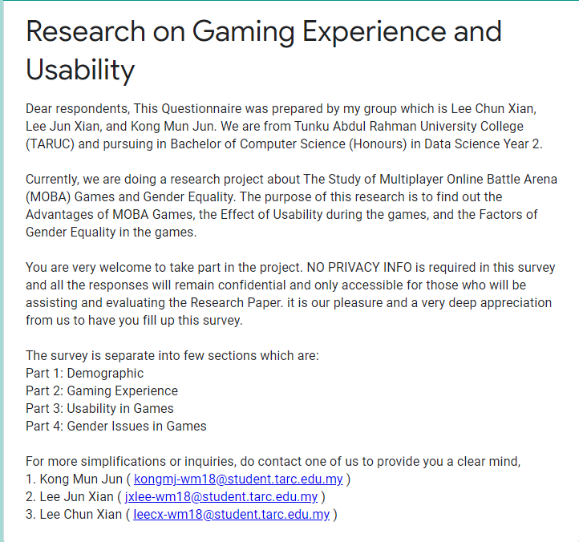**

**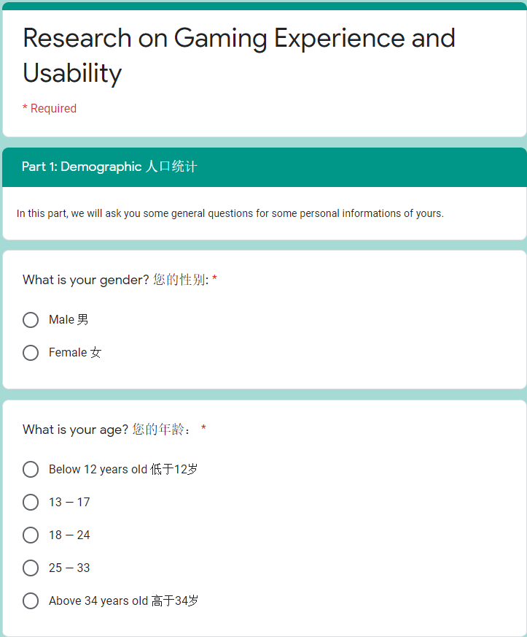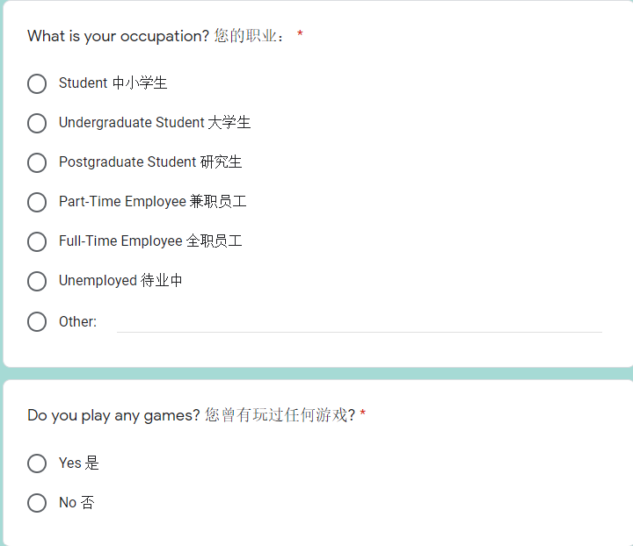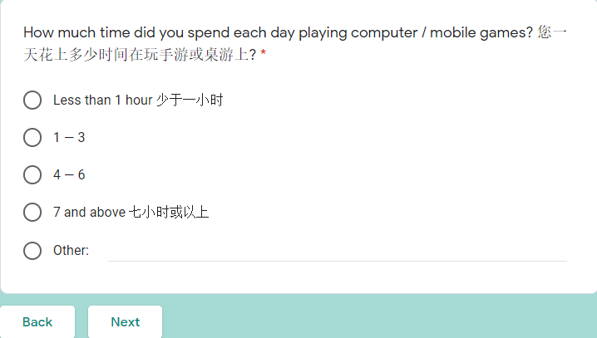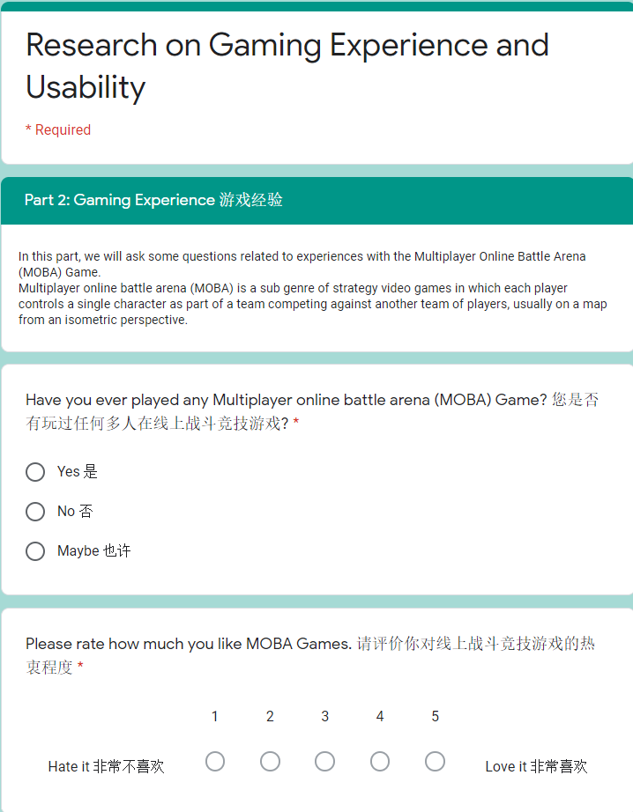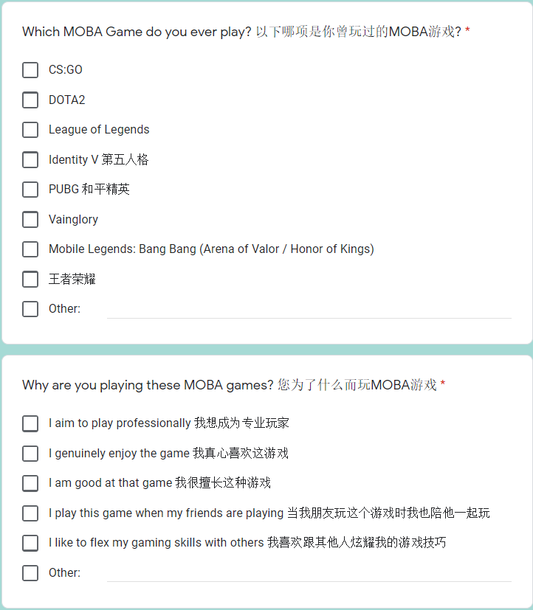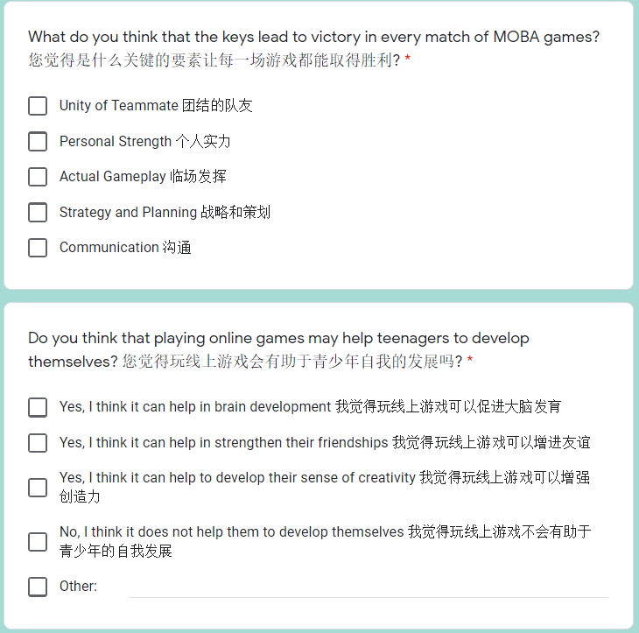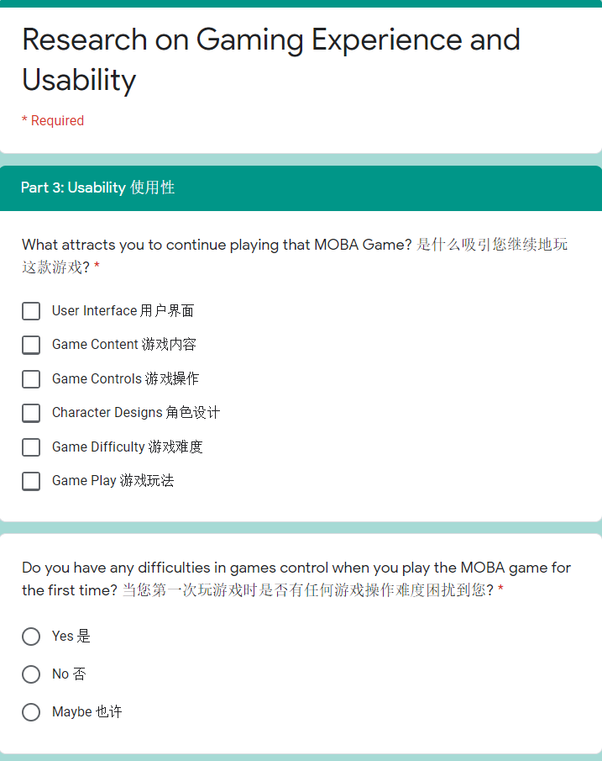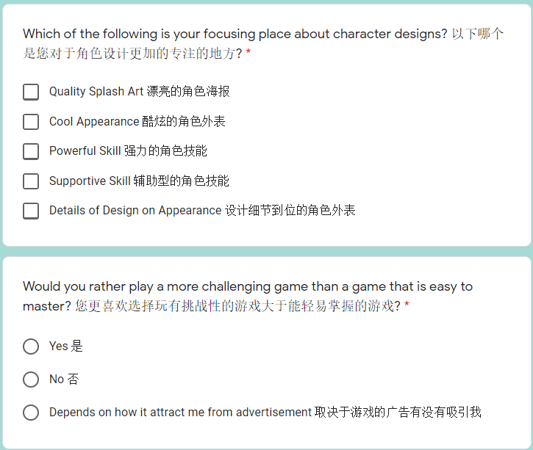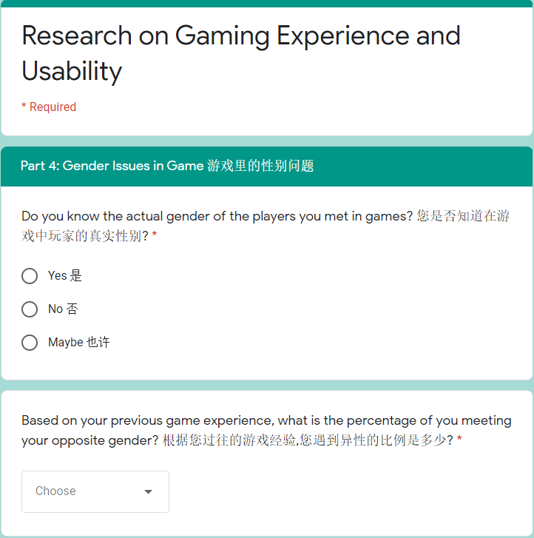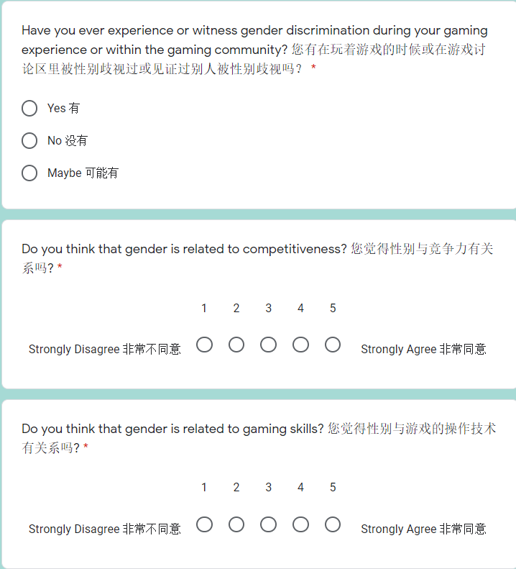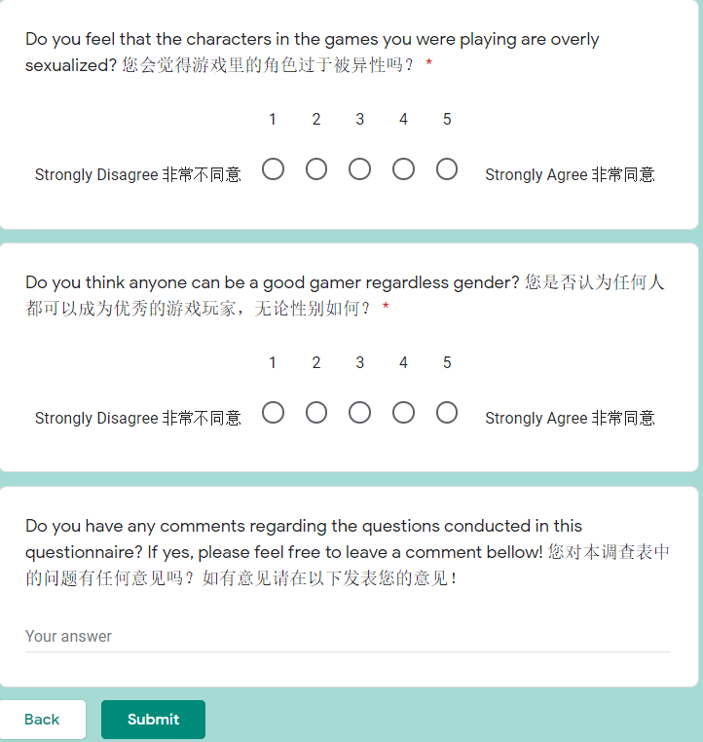**

**Appendix II (Sample Response of Questionnaire)**

**